The Farm Creek Marsh, Rowayton, Ct.

Prepared by Livia DeMarchis and Charles Liu, Fall of 2003
(with editorial and addendum comments by TGS)

(Note this report is the product of a class project by two Yale undergrads in an Ecosystem Science course. Neither of them have ever done anything like this before and this report should not appear in any way to represent a consulting job associated with Yale University. It is what it is - our views on the marsh as observed on 3 occasions. The single spaced indented text is the annotation added by Tom Siccama, the faculty advisor on the project. This project has already taken too much time and rather than take an entire spring semester to incorporate the professors views and opinions with the students learning process and report, I will just stick them in. My comments are redundant on theirs in places but I wanted to spell out what I saw and what I think)

Introduction

Farm Creek is a small salt marsh covering approximately 4 acres in the town of Rowayton, in Connecticut’s Western Coastal Ecoregion (Dowhan and Craig, 1976 and Johnson, 1981). The area is bordered to the North by McKinley St., to the West by Roton Ave., to the East by the backyards of homes along Farm Creek Rd., and to the South by the old Sammis St. bridge. Many of the citizens living around Farm Creek take an active interest in this area, which provides a peaceful setting for the recreational enjoyment of nature and a haven for desirable wildlife. Farm Creek was donated to the Nature Conservancy in 1973-74 as the Kulze Preserve by Mr. William J. Kulze (Johnson, 1981), and has since been transferred to the Norwalk Land Trust for management. In 1981, the Conservancy completed an inventory of the area, which included information on the marsh’s history, hydrology, geology, and plant and animal composition. A couple of maps were made at that time, situating the site with reference to surrounding streets and mapping vegetation types. These documents have been helpful in the present study of Farm Creek, which was initiated by a group of Rowayton residents.
(At the onset of this study we obtained a copy of a copy of a copy etc. of the report complied by Loretta Johnson in 1981 for the Nature Conservancy. It appears that there was an earlier context in the mid 1970's in which 2 Yale students did a study. We have not found that study although we did track down one of the authors Phillip Dibner in California. He remembers doing the project but did not have any data that he knows of. Although he did say he was going to go through his files and if he found something he would contact us. I don't hold out much hope but we did put a bug in his ear and he will follow up if he runs across anything. We have not followed up on Yvonne Gonzalez which might be done. I am tracking down Loretta Johnson which has run a trail through TNC, Conn. College, a 90 year old retired Prof. at Conn. College then on to UCONN and finally a track to Kansas State University. I have left phone messages and e-mail but as of yet no response. (She responded 1/24/04 and will look through her files).
There is a very important statement in the 1981 report which I would like to know about - it is stated that in 1981 a permanent grid system of plots was established on the marsh and the vegetation mapped. That data exists some where. There is a moral here - data keeping is relevant especially if there is a prospect stated of long term monitoring. We need to find that data. One useful step which came out of the inquiry was finding at TNC an annotated color map of the marsh - the original seems to be at TNC and they scanned it and sent me a copy which is in this report (figure 1). Although the text on the map shown below is illegible, there is a document at the end of this report which contains the words spatially oriented and copied from the TNC original.)

Figure 1. TNC scanned map from 1981 study
.
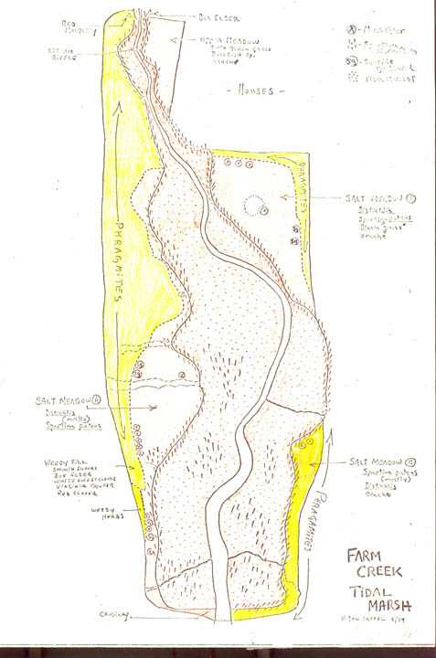
Figure 2. Aerial photo illustrating the marsh at what appears to be nearly high tide in 2000.
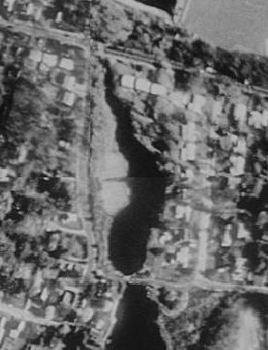
Neighbors of Farm Creek have recently organized FarmCreek.Org., “a group of concerned people who wish to husband this quiet and beautiful salt marsh. [They] wish to ensure the creek remains clean and clear for flora and fauna to thrive and to retain its natural beauty” (FarmCreek.Org, 2003). Some of the issues this group would like to address include: the health of the creek; the maintenance of a “healthy balance between the water quality, the inhabitants and the vegetation that surrounds [the] salt marsh” (FarmCreek.Org, 2003); and potential research that can be conducted to assess the health of the creek.
In 2003, FarmCreek.Org sought advice from the Yale School of Forestry and Environmental Studies (F&ES) regarding the current condition of the Farm Creek ecosystem. We took on the project as part of a semester-long course, “Ecosystems: Patterns and Processes.” Our primary goal was to assess the current health of Farm Creek. “Health” is not, however, a clearly defined term here. It is clear that the site is not in its pristine state, but this does not necessarily mean it is unhealthy. In considering the system, it is important to be clear that there are three relatively distinct structural/vegetative areas of the site which have been looked at in this study in trying to assess “health”:
1) the creek itself, where the Farm Creek fresh water flows even at low tide and including all the "mud flats" which are routinely covered by high tide;

2) the salt marsh region, where cord grasses occur;
3) the “upland” edge area buffering the marsh from surrounding human land use- both east and west sides which differ markedly.

(There was expressed a concern that the present situation is in some way "not healthy" and even seems to suggest that the aggradation of the marsh vegetation out onto the present day mud flats is not natural or expected. It is my opinion that it is very possible that the original situation may have been as I have illustrated in the three accompanying photos [fig. 3-5]. That is it was a grassy marsh with the stream flowing though it. The present extent of mud flats is a degradation of the marsh which may have occurred since settlement of the area going back 300 years. If this presumption is not true, it is also perfectly natural for the marsh to aggrade up to the creek bank and look like the photos. These photos were taken on a marsh in East Haven. The upper photo was taken in 1911, the middle in 1932 and the bottom in 1976. If your marsh aggrades to look like this - that would be a normal and good thing. The loss of more marsh grasses and the expansion of the mud flats would be a bad thing. You will not stop either from happening and certainly the present configuration is not stable and change will occur. These photos show you the value of such long-term pictures - as long as someone keeps track of where they are for 100 years or more. The fourth photo is of the Farm Creek estuary looking North from the bridge taken by Livia in the fall of 2003.)

Figure 3 - 6. Figures 3, 4 and 5 are of a salt marsh in East Haven taken from the same spot over a period from 1911 to 1976. Figure 6 is of the Farm Creek marsh taken looking north from the Sammis St. Bridge in the fall of 2003.

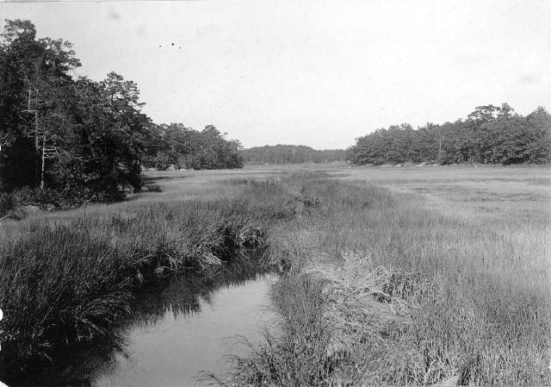19111932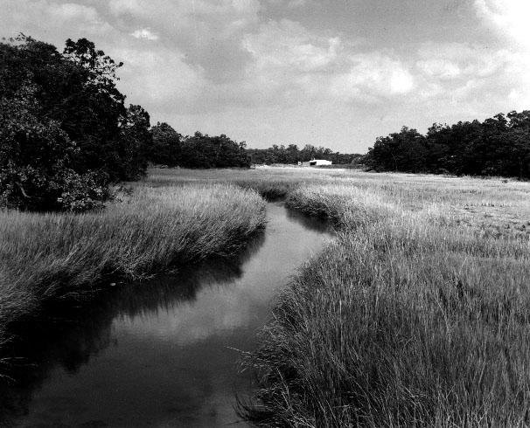1976
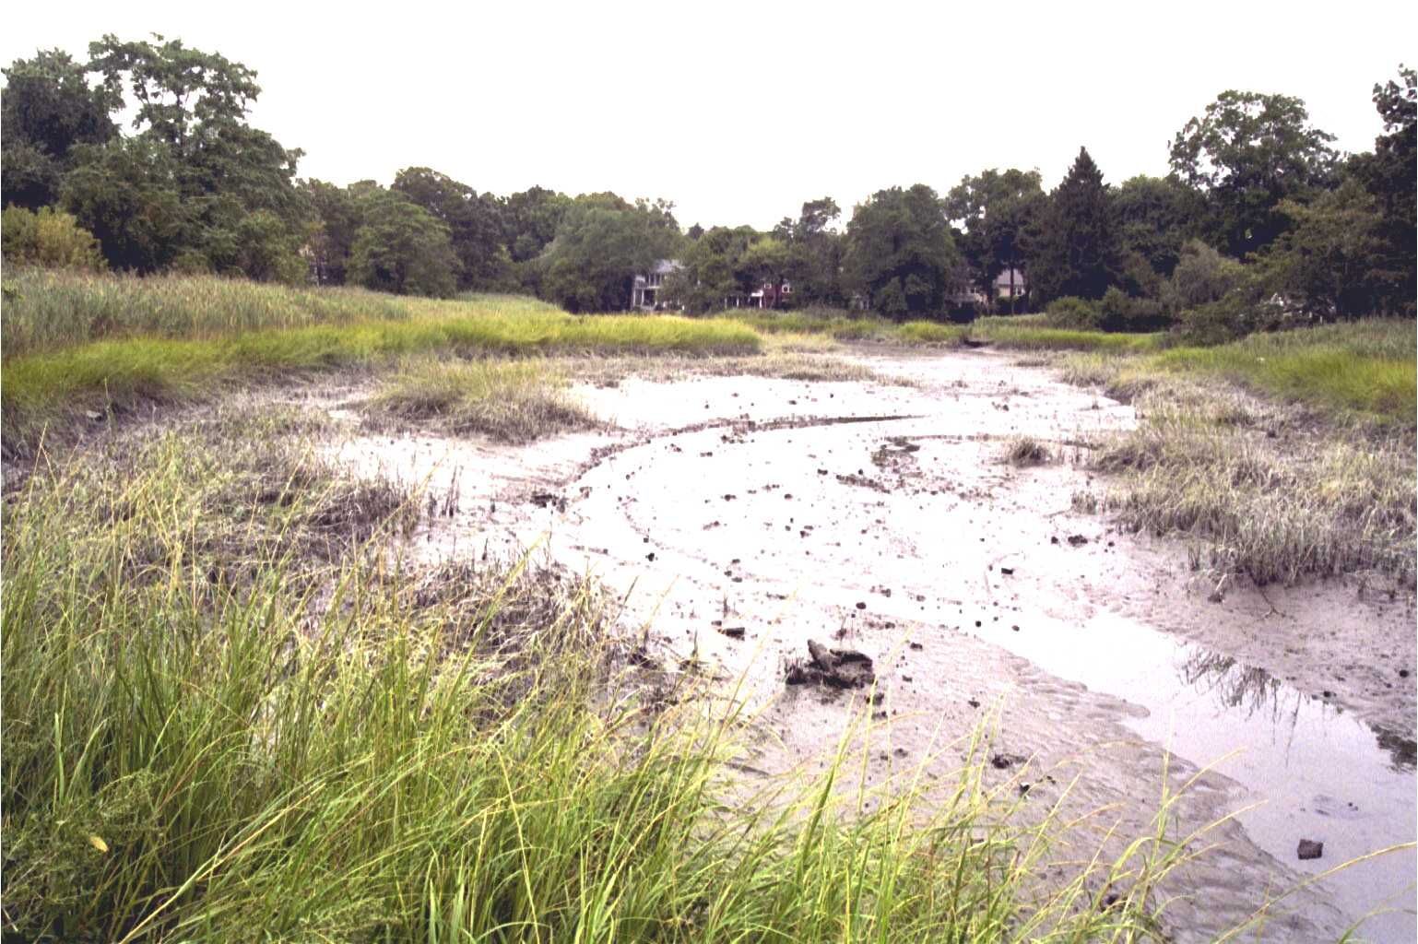

Methodology

We visited the Farm Creek on three occasions (9/15/03, 9/22/03, 10/20/03). On the first trip, we walked around the area with members of FarmCeek.Org, listening to the questions and concerns they had about the area. One concern was the weedy vegetation growing on the upland edge of the Roton Ave. side of the marsh. Noting that the peninsula Southeast of Farm Creek, which extends into the lower part of the Creek, has native vegetation as opposed to weedier nonnative species, we planned to visit the area on a subsequent trip.
On our second visit, we toured the peninsula, walking around the border where “upland” edge vegetation meets the high-tide bushes and cord grass. We wrote down all of the native marsh border vegetation growing here, and took photos of the vegetation and the shoreline. In addition, we did a survey of the vegetation growing on the Roton Ave. edge of the marsh, creating a list of native and nonnative species. We later used the inventory of native species from the peninsula to make a list of species that might be suggested for native vegetation "restoration" along the Roton Ave. border, and sketches were made to show what the Roton Ave. border might look like with native vegetation. In addition to surveying vegetation, on our second visit, we measured the temperature of the marsh water both at its outlet under the Sammis St. bridge and at its inlet South of McKinley St. We also took water samples from both of these points, which were brought back to lab and measured for salinity.
Our third visit involved discussions with several neighbors whose backyards border Farm Creek on the McKinley St. and Farm Creek Rd. sides. We had noted on previous trips that the Phragmites along the marsh border in some yards was being “managed” with apparent success by homeowners. In addition to surveying the ways in which Phragmites was being managed, we looked at the soil in the area by digging a number of small soil pits. Some were dug in the center of the creek bed, while others were dug on the Roton Ave. edge of the marsh (one close to the Sammis St. bridge, another in the Phragmites approximately thirty feet East of Roton Ave., and yet another about fifty feet from the Roton Ave).
In addition to work in the field, we used Digital Orthophoto Quarter Quads from 1995 and 2000 to try to assess the area of the central marsh region where vegetation was not growing. The images were imported into ArcView 3.3, and a polygon was drawn around the area of interest; because the images were georeferenced in Connecticut state plane, the software was able to calculate a value for the selected area.

Data

Salinity

A concern was raised about freshwater entering the creek at its inlet, so rudimentary salinity measurements were taken to see if anything unexpected was found in the creek with regards to the mixing of salty tidal water and freshwater. We collected two water samples, one at the outlet just under the Sammis St. Bridge where tidal water enters and exits in creek, and another at the Northern end of the creek where freshwater runs into the creek. Samples were collected in small plastic bottles and brought back to the lab where salt content was measured. Salinity at the outlet was 5.35 ppt compared to 0.3 ppt at the inlet. Both measures were taken at low tide on September 22, 2003. The number of samples we took is not sufficient for a rigorous study of the creek’s salinity, but nothing surprising was noted in the measurement from the inlet as compared with that from the outlet. The average salinity of ocean salt water is 35 ppt and the average salinity of Long Island sound water is 29 ppt, so the salinity of the creek, even at the outlet where saltier tidal water enters, is comparatively low. However, a salinity measure lower than sea water would be expected at the outlet as the creek contains a mixture of freshwater and salt water.

Creek Area

One concern expressed by neighbors was the perceived loss of creek area to encroaching vegetation. We tried to investigate this concern using aerial photographs to estimate the area covered by water as opposed to cord grass and other marsh vegetation. We were able to get two digital orthophoto quarter quads of the Northwest corner of Norwalk, CT showing Farm Creek: one from 1995 and another from 2000. The 1995 photo came from CT’s GIS website (http://magic.lib.uconn.edu/cgi-bin/MAGIC), and the 2000 image came from Yale’s Center for Coastal and Watershed Systems. Both images were measured in CT State plane—NAD 83 ft, and given this information, it was possible to import them into the mapping program, Arc3.3. Arc3.3 allowed us to draw a perimeter around the area covered by water in each photo and gave a measurement for the perimeter drawn and the area it contained. For the 1995 photo, this figure was approximately 72, 160 sq. ft. or 1.66 acres with a perimeter of approximately 1,945 ft. For the 2000 photo, the measurements were approximately 67, 064 sq. ft. or 1.54 acres contained within a perimeter of approximately 1,774 ft. While these measurements show a decrease in area from 1995 to 2000, no valid conclusions can be drawn from this data because the amount of area covered by water in each photo is based primarily on the level of the tide, and we could not compare the timing of the photos with relation to the tides. In addition, the data obtained from aerial photos is not precise enough to be useful or accurate because it is very hard without higher resolution photos to account for the subtleties in how vegetation grows around the creek water.

Discussion

Past Human Impacts

The Farm Creek marsh has been experiencing the effects of human land use for more than three centuries. Even when early maps of the area were made in 1886, people had started filling areas of the marsh for the purpose of constructing homes. In the 1981 Nature Conservancy document, Johnson stated that in the late 1960s, material dredged from the Five Mile River was disposed of by dumping it into Farm Creek, and fill from construction on Roton Ave. continued to be added to the marsh until 1973 (Johnson, 1981). In digging our soil pits, we did find signs of fill on the upland edge of the Roton Ave. side of Farm Creek, although it is not clear that this fill was necessarily the result of construction dumping.
(This could be misleading. The Farm Creek marsh includes not just this inner marsh but also the marsh all along the creek out to the sound. There is no evidence of any dredge spoil ever being dumped in the preserve marsh inside the bridge.)

In the 1960’s, an attempt was made to convert the marsh into a freshwater pond by constructing a dam under the Sammis St. Bridge. This structure was washed away relatively soon after its construction. In the Conservancy report, Johnson claimed that enough rubble remained from the derelict dam to impede the flow of tidal waters (Johnson, 1981); however, this is not currently occurring in our view. Furthermore, Johnson implied that the hydrology of the system was affected by the construction of a dam North of the marsh, which made a freshwater pond and reduced the flow of a freshwater stream that had historically entered the creek (Johnson, 1981). While it is true that the dam has resulted in the formation of a "settling pond" North of McKinley St., normal amounts of freshwater still flow into the marsh from the North. The major effect of the Northern dam is that today the lake acts as a settling pond catchment area for sediment carried by the stream. Thus before the pond as made, the Farm Creek would deposit its normal stream sediment into the head of the tidal part of the creek. In surveying Farm Creek, we did not find that sediments were accumulating in the system due either to materials flowing in from the North or to runoff from storm drains.
(All man made obstructions to tidal flow in an estuary are "bad". The nice bridge with a path over it is "bad". This is one of those cases where bad is nice and acceptable as long as it is there. However, what would you do if it was not there and someone suggested building a bridge - you would freak out. The effect of the bridge - or rather the filled approaches to the bridge restrict the flow of the tide. If you want to know the effect of this structure on the tide range you could do the following: Find a nice sloping dry rock near the bridge on the downstream side and watch as the tide reaches full high and just starts to turn - if at this point water is still running in under the bridge, then the bridge has obstructed the flow. The constraint has not allowed the interior to fill before the tide turns- thus it is still running in to fill the interior even though the tide on the outside has turned. If there was a huge marsh on the interior this would be easily measured, but the small size of this marsh probably makes detection of this phenomena not possible - it is too subtle. On the same note keep in mind that sea level is rising each year by about the height of the type you are reading [2 -3 mm]. Since 1981 the sea level has risen about 1/3 inch give or take. Extrapolating this rate of sea level rise back say 300 years to the time of settlement the marsh surface must have been about 2 - 3 feet lower than it is today. The marsh sedimentation processes have to keep up with this or the marsh will turn more and more into a mud flat. There are two sources of sediment - obviously - the sea water and the Farm Creek + the organic material which grows each year and may not decompose (peat) and thus serve to also build up the level of the grassy marsh.)

Current “Health”

FarmCreek.Org is primarily concerned with assessing the current health of the site, and as mentioned earlier, for such discussions, we have decided to consider three separate components of the system: the creek or water filled area itself including the mud flats, the marsh area, and the upland edge. When concerns about a system are stated in terms of the “health,” this terminology raises the question of how “health” should be defined. When asked, some neighbors have said a healthy marsh is one that is good for wildlife, while others have simply said they’d like to see the marsh in its “natural” state, but what is the natural state?
Our limited study indicates that there is nothing inherently unhealthy about the Farm Creek ecosystem, with the exception of some weedy invasive species which have grown up along the upland edges of the area. The conclusion of general health holds when either wildlife or “naturalness” is considered as a criterion.
Some of the concerns that have been raised by FarmCreek.Org seem to be with changes that have been noticed taking place in the system. Most notably, it has been noticed that the system seems to be aggrading or sediment buildup has occurred in the creek bed. Ecosystems are never completely stable, meaning that they never reach a state at which they do not experience change (Scheffer and Carpenter, 2003). The natural state of an ecosystem is not static, but constantly changing, and the current changes that worry some neighbors are perfectly "natural" in that they are in line with ecological processes that would have occurred prior to European colonization and, by extension, prior to significant human use of the area.

The Creek
As far as the creek itself, or the area covered by flowing water, is concerned, our relatively limited study shows no signs that the area inundated by water is polluted or unhealthy. As mentioned above, we did not find that sediments were flowing into the system from “unnatural” (i.e. anthropogenic) sources. The small amount of water chemistry that we completed did not produce any surprising results and there were no signs of runoff, oil spills or other pollution leaching into the system. As mentioned, our limited salinity measures do not point to anything inherently unhealthy or surprising in the functioning of the creek.
(Concerns about the one or two storm drains which outflow into the edge of the marsh are unfounded in terms of "sediment". When streams or storm drains enter any body of water such as this large estuary they would naturally build up a delta of sand if they were carrying sediment in any quantity. This is not the case. With respect to the Farm Creek itself it is hard to say what the natural sediment deposition pattern would be because of the roads and upstream disruptions to the natural flood plain over 300 years (between the dam and the road))

These conclusions agree with the findings of one participant in the FarmCreek.Org April meeting, who performed some water tests on the creek and found the water to be of fine quality (FarmCreek.org). A soil pit dug in the middle of the creek bed revealed about 18 inches of silty peat between the surface and the underlying organic sand. This agrees with the Nature Conservancy’s 1981 statement that the soil here is a West-brook peat (Johnson, 1981). There was no evidence of an oil lens or pollution running through the peat, which supports the idea that this is not an unhealthy system.
Interestingly, rhizomes, or plant roots, were found all the way throughout the peat even at the very center of the mud flats and up to the creek stream channel. The presence of rhizomes in the creek bed’s mud flats, areas that are now free from plants and considered open water zones, suggests that the creek’s open flats were historically more narrow than today, with marsh grasses and possibly even cattails growing further from the current shores and into the water- much like the East Haven marsh shown in the previous photos (Fig. 3-5). This observation addresses a fear that has been voiced by FarmCreek.Org. Members of the organization have said they are afraid that they are “losing” open creek area to the process of sedimentation and to the growth of islands of marsh grass closer to the center of the creek, which they feel could in some way indicate an unhealthy situation. The measurements of creek area covered by water in 1995 vs. 2000 suggest that the area without marsh grass may be decreasing, however, the measurements taken from aerial photographs are not conclusive on this point because we were unable to find the time of day at which the photographs were taken, and the level of the tide at different times during the day will affect calculations. Regardless, even if marsh grass is definitely growing towards the creek at the center of the marsh, this is not cause for alarm. Instead, the process of marsh grass growth into the creek probably represents the marsh returning to a state more similar to the way it was before anthropogenic construction activity in the area caused erosion and silting to cover the original plants. Indeed, if one defines the “natural” state of the system as the way the area might have looked before European settlers came, then Farm Creek today is actually moving closer to such a "natural state".
( Keep in mind that the creek itself, except maybe in an occasional flood, is contributing an extremely small amount of water to the whole of the preserve area relative to the tidal flux- the fresh water effects are really trivial - sort of like peeing in the ocean!. However the long term effects of the upstream pond or lake are quite great. This pond prevents the natural source of sediments from reaching the estuary. Now there are two points here - one is that when all the land in the watershed was open agricultural land or even during the housing development era there would have been an excess of sediments which would have been "bad". But now that the landscape has stabilized and there are no extensive new housing tracts or bare agricultural fields, the sediment loads would be back to "normal". However the presence of the pond effectively serves as a settling basin above the marsh and cuts off any natural sediment from reaching the marsh, This is unnatural. )

The Marsh
In further addressing the question of whether concern should be raised over increased sediment levels, it should be pointed out that some of the concern associated with wetlands today is the threat of losing them to erosion. The opposite process is occurring at Farm Creek. In surveying the area, we did not find that significant sediment was being carried into the marsh, either from the freshwater farm creek entering from the north or from storm drains and road runoff feeding into the marsh. Sediment is, however, aggrading in this system due to tidal water imports. When tidal water flows into the marsh, it carries with it organic sediments and silt kept in suspension by turbulence in the bay and Long Island Sound and by the fast flowing tidal influx water. Once in the marsh, dense grasses prevent turbulence, allowing sediments to fall out of suspension as deposition. The build up of this deposition leads to rising levels of sediment in the creek’s open flats and salt marsh. Thus, while the rise of sediment worries current residents, it is part of a natural process. Sea level rise, which occurs at about 2 mm a year, almost perfectly matches the rate of sediment accumulation, so we conclude that only trivial amounts of unnatural sedimentation are currently entering the system due to inputs from drainage pipes.
While soil pits revealed signs of past human activity in the underlying marsh soil, our study does not show a need to worry about the health of the soil here. Furthermore, the marsh cord grasses that are growing here appear to be healthy, and the marsh component of the Farm Creek ecosystem appears to be in general good condition.

Upland Edge
While our study has not found signs of "unhealthiness" in the creek or marsh components of the Farm Creek site, the one portion of the system that is not as “healthy” as it might be, if one wants to maintain native vegetation, is the upland edge area.
Soil pits dug in the upland area revealed anthropogenic fill, but this in itself is not cause for concern because the fill is not actively harming the system. A soil pit dug on the west side of the creek, about thirty feet East of Roton Ave., revealed anthropogenic fill under the Phragmites growing here. This fill was noted in the Nature Conservancy’s survey, which also stated that the local Preserve Stewardship Committee removed much of the fill in the mid 1970s (Johnson 1981). The belowground material found on the Roton Ave. bank is not uniform; a soil pit dug near the Sammis St. bridge revealed a large pile of oyster shells, which should not really be called fill, and which in similar settings in Connecticut, has been a sign of Indian middens. One could view this as native Americans throwing their trash into the marsh. Because the marsh peat does not provide a solid foundation for construction activity, it is probable that fill is present under the houses along the Eastern bank although soil pits were not dug on this side.
(Directly behind the sign which identifies the preserve and adjacent to the edge of the Spartina marsh grass there is a thick deposit of oyster shells. We happened upon this in our looking at the soil. I had not seen it mentioned in any of the previous reports. It is of course possible that some one dumped oyster shell there but based on my observation of these kinds of shell heaps elsewhere in CT it certainly looks like an Indian midden. This also indicates that this limited area near the sign has not been filled by modern soil fill as has most of the rest of the roadside to the north of this point).

Today, it is impractical to suggest removal of fill remaining on either side of the marsh as it has been here since at least the 1970s and is not currently harming the system. However, the presence of fill likely helped Phragmites gain a stronger foothold in the marsh, and the Phragmites continues slowly growing toward the creek flat today. Phragmites tends to prefer growing in areas that have been altered hydrologically (Chambers et al. 2003). Anthropogenic fill alters marsh hydrology, and Phragmites generally seems to become established better in upland marsh areas where fill has been left, although this phenomenon is not well understood. It is not completely clear if the Phragmites is currently moving further out in the Spartina areas. Systematic long term mapping of the area and good record keeping would be needed to make this comparison in the future.
Even further upland, on the edge between Roton Ave and the marsh, one finds a tangle of nonnative and often weedy species growing. The replacement of plant communities associated with salt marshes by weedier species has been a subject of research attention and concern (Bertness et. al. 2002). If the members of FarmCreek.Org would like to move the edge system closer to precolonial New England conditions, the growth of these nonnatives is undesirable and some suggestions follow as to what can be done to improve this component of the site.
(It is potentially a big deal about the "restoration" of the edges of the marsh. These are the only areas which are an artifact of the surrounding development and are very "unnatural". It is inconceivable that anyone is going to let you interfere with the marsh processes in the marsh itself. However the edges are in sorry shape and could be "restored". However this is "gardening" in a big way and as in any garden will have to be cared for year after year if not week after week. First you should very seriously take a look at the forest edge along the peninsula southeast of the preserve. This appears to us to be quite exactly what the edge would have looked like before European colonization. The more or less open woods comes right down to the shore. I am guessing that the Land Trust and the TNC and the DEP will never let you do anything - but if you do get some permission you will need to remove all the non native vegetation along the road down to the bare soil and then plant native species. Not just to bare soil, but you will have to remove the roots and rhizomes of the non native species - a formidable task. (PS-Phragmites rhizomes, if you never have seen them, look much like half inch white PVC water pipe. They are hollow (except at the nodes) and are about as tough at PVC pipe. These rhizomes are at a depth down to maybe a foot and are not easy to get out - to say the least!)
I doubt that you should plant native species from a commercial source, you almost have to transplant some from maybe the peninsula. These species and genetic individuals will have to be adapted to the saline edge environment. We suggest for a start taking the distance between two telephone poles and doing this in a big and careful way. Keep in mind that it will look like hell for a long time. It will also open up the vista such that you will see the neighbors across the marsh and they will see you. Given 10 years of careful attention you should be able to figure out if it is possible to accomplish this goal. If so, you might then consider expanding the "experiment" to the entire extent of the area on the west side.
Alternatively you could just try to edit the present vegetation a few square meters at a time- again after horrendous getting of permissions. I doubt that this would work - you really have to get rid of the root systems of the plants that are there now. Most of the non-native plants will sprout back from the roots in infinite numbers and the use of herbicides month after month is certainly questionable.

The east side is a very different matter - it is kind of cool to see the "results of the experiments" which have been carried out in the name of lawn maintenance in the mowing of the Phragmites. This is a feasible project for "restoring" the entire east edge but unless all the land owners agree to do it it would be like trying to pump out a square mile of Long Island sound and keep it dry. A foolish idea. So it is either all or nothing. It is clear from the guy on the end whom we visited that it will work - he has 20 years of results to prove it. But even there he has probably done illegal stuff in two contexts, one is mowing a marsh which is disturbing a wetland and he has done it on the preserves land - we think. So permission from the TNC, Land Trust and DEP would be required as well as the long term commitment by all the land owners - good luck!!)

Summary
In general then, Farm Creek represents a “healthy” system. Most of the concerns voiced by neighbors are connected to changes taking place at the site due to natural aggrading processes. The important thing to remember is that change does not indicate that something in the system is necessarily amiss. Change is not inherently bad, but is a normal process throughout nature.

Recommendations

There is no justification for intervening in the central creek open flats or the marshy cord grass areas of Farm Creek in the name of "health,” and nothing could be done to predictably sway the course of ecological processes here anyway. This said, there are, however, some management issues regarding the “upland” edge borders that deserve attention. To the West of the marsh, vegetation bordering Roton Ave. is overgrown by a number of nonnative species, while on the Eastern edge, the growth of Phragmites is the major concern. Any discussion of invasive species must acknowledge that they are not inherently “bad,” but in most cases, this is the value placed upon them by humans who would like to maintain native species. Nonnative species change the aesthetics of an area and can alter ecosystem processes. In the case of Farm Creek, the presence of nonnative species on the marsh border is mainly an aesthetic concern. While it is possible that the weedy tangle of nonnatives adjacent to Roton Ave. is potentially restricting for certain waterfowl, our limited survey could not provide adequate information to make reasonable judgments about the area’s wildlife.
Based on surveys of the peninsula southeast of Farm Creek and of neighboring properties where "gardening" has in some cases succeeded in controlling Phragmites, it is possible to make some “gardening” recommendations for improving the border on both banks of the creek.

Eastern Border
The marsh’s neighbors on the Eastern border are unintentionally running a number of “mini experiments” testing the most effective ways to manage the balance of Phragmites and marsh grasses on their property.
The O’Sullivans have been mowing back the Phragmites on their property for the past twenty years as if it were an extension of their lawn. Mr. O’Sullivan got the idea to mow the Phragmites and some of the marsh grasses in his backyard because he was aware that salt hay was once a product sought after and harvested as feed for horses. He decided that if cutting it had worked in earlier times, he could try it too. Mr. O’Sullivan first cut the Phragmites by simply pushing a lawn mower through it, and since he started, this has been the usual method used, although he has also tried a sickle bar. In the past, Mr. O’Sullivan had been mowing the area where Phragmites might grow once a month or so, and this was enough to keep the balance of grasses he wanted. However, he has recently employed a professional lawn service, which currently cuts the area once a week. Because the area is sometimes inundated by relatively salty estuarine waters, even with constant cutting of marsh grasses and Phragmites, normal lawn grass won’t grow. Instead, the marsh grass, Distichlis spicata has grown up in the area that was once completely covered in Phragmites (O’Sullivan, personal communication).
Further up the Eastern side of the creek, another property owner has been cutting back Phragmites, but Distichlis spicata has not started growing back because the cuts are very recent. Still further up the creek, there is a property on which it almost looks as if the owner has been trying to figure out the best management strategy by mowing different areas at different intervals. As it turns out, the pervious owner of this property had been cutting back the Phragmites for eight years and marsh grasses started growing in. The property was then sold and the grasses were not cut for a season before being cut once again at the end of this season. In areas where the Phragmites has just recently been cut, marsh grasses should be able to grow back in with time. In addition, shrubby plants such as marsh elder and seaside rose would do quite well if established right along the edge of the marsh. However, this would prevent mowing and in no time the phragmites would take over again!!!!!
Currently, the marsh border on the Eastern bank is being managed in a rather patchy system based on the various efforts of different neighbors. If the desire is to limit Phragmites and encourage the even growth of marsh grasses, a more coordinated system of managing the bordering vegetation would be recommended.

Western Border
Since mowing the Phragmites has worked in patches on the marsh’s Eastern bank, it is probable that it could be cut back on the Western bank as well. If there is a desire to try to manage the Phragmites on the Western bank, mowing should be started at a small scale and expanded with time. The process could begin by mowing an area approximately ten feet deep (from Roton Ave. toward the marsh), and once this area is under control, another five feet of mowed area could be added in subsequent years. Distichlis spicata plugs or rhizomes can be planted in the area where Phragmites is cut back, and bushes such as marsh elder and seaside rose could be planted here. However, these marsh grasses will not succeed unless there is a flux of high tide water at least several times a month or more often.
(I wonder of it would not be better to mow from the marsh side toward the land. It is out here that the Phragmites is not so intertwined with rose bushes, poison ivy and other shrubs making cutting difficult. This would allow mowing the entire length of the marsh say once a month say 10 feet the first year and then 15 and then 20 etc in the following years? This could be in concert with the other suggestion of the "restoration" of the more upland edge starting from the road and working out. Mow higher than Mr. O'Sullivan - cutting two or three inches higher than he is would equally restrict the Phragmites while allowing more vigorous Distichlis development.)

There is a variety of nonnative species on the Western edge of the creek in addition to Phragmites (Table 1). If the desire is to remove nonnatives and replace them with native vegetation, this process can be started by taking the area between two telephone poles, for example, and editing out the unwanted plants. The following tables (Tables 1-3) give an idea of some of the species that should be removed and what might be planted in their place.
The vegetation planted to replace unwanted species will have to be carefully tended because becoming established will be an uphill battle. The area should first be cleared of as much of the unwanted plants as possible, removing as much of the roots as is reasonable. Many saplings of those species chosen to replace unwanted vegetation should then be planted. The fundamental idea is to overwhelm the area with the “good” plants so that they have the best chance of becoming established. A word of warning: the process will take consistent, deliberate input of much human effort ($$) over the course of many years and probably will not rid the area of Phragmites completely. Furthermore, the weedy species currently present will just reinvade if the job is only done timidly or half-heartedly.
(Poison ivy is a very very native species and should not be looked on as bad. If you do you are just being hypocritical in your efforts to restore the natural edge vegetation.
It is not clear to me if editing the current vegetation or "starting over" is the way to go. There are huge legal issues in doing any tampering with wetlands in the name of "restoration."
You know - another option is to try to increase the area of the marsh. That is try to get the marsh to move further west and by "dredging" (lowering by removing a few inches) the surface a few inches so the tidal water will come up further. Then plant marsh grass. I guess this is a sub set of the mowing from the outside in mentioned above).

Current Plants on Western Creek Border (along Roton Ave.)

Table 1. Nonnative “Bad” Species
Common Name | Scientific Name
Ailanthus | Ailanthus altissima
Eastern Burningbush | Euonymus atropurpurea
Common Ragweed | Ambrosia artemisiifolia
Privet | Ligustrum obtusifolium
Honey Suckle | Lonicera sp.
Mugwort | Artemisia vulgaris
Multiflora rose | Rosa multiflora
Norway maple | Acer platanoides
Phragmites | Phragmites australis
Poison Ivy (native, but not desireable here) | Toxicodendron radicans

Table 2. Native “Good” Species
Common Name | Scientific Name | Shape
Groundsel Tree | Baccharus halimifolia | shrub/small tree
Bayberry | Myrica pensylvanica | Shrub
Black Cherry | Prunus serotina | “spreading” tree
Black Locust | Robinia pseudoacacia | Tall
Box Elder | Acer negundo | rounded tree
Green Ash | Fraxinus pennsylvanica | rounded tree
Oaks
Northern Red | Quercus rubra | tall tree
White | Quercus alba | tall tree
Seaside Rose | Rosa rugosa | shrub
Shadbush | Amelanchier arborea | tall tree

Table 3. Native Plants on Point

Common Name | Scientific Name | Comment
Groundsel Tree | Baccharus halimifolia | shrub/small tree Dark green leaves with white/yellow flowers
Bayberry (Northern) | Myrica pensylvanica | shrub
Black Cherry | Prunus serotina | “spreading” tree
Golden Rod | Solidago sp.
Green Briar | Smilax sp. | Very prickly
High-tide bush/Marsh elder | Iva frutescens
Poison Ivy | Toxicodendron radicans | Not friendly
Red Cedar | Juniperus virginiana
Red Oak | Quercus ruba | Probably too big to try replanting near road
Sassafras | Sassafras albidum | Without much understory, high leaves, open canopy
Seaside Rose | Rosa rugosa | shrub
Shadbush | Amelanchier arborea | Short tree, multistemmed
Silky Dogwood | Cornus sp. | Not certain how this will deal with salt water, perhaps better closer to road
Switchgrass | Panicum virgatum | Requires a lot of sun
Sycamore | Platanus occidentalis | Not certain how this will deal with salt water, perhaps better closer to road
Turkeyfoot | Andropogon gerardii | Very rare
Virginia Creeper | Parthenocissus quinquefolia | Crawls up trees
Winged Sumac | Rhus copallinum | “spreading” shrub

Bibliography

Bertness, Mark; Ewanchuk, Patrick; and Silliman, Brian. 2002. Anthropogenic modification of
New England salt marsh landscapes. PNAS. 99 (3): 1395-1398.

Chambers RM, Osgood DT, Bart DJ, Montalto F. 2003. Phragmites australis invasion and
expansion in tidal wetlands: Interactions among salinity, sulfide, and hydrology.
Estuaries 26 (2B): 398-406.

FarmCreek.Org. http://www.farmcreek.org. (15 November 2003).

FarmCreek.Org. April Meeting. http://www.farmcreek.org. (6 December 2003).

Johnson, Loretta. April. 1981. Natural Resources Inventory: Farm Creek Complex, Rowayton,
Connecticut. The Nature Conservancy. Connecticut Chapter.

MAGIC website. 1995 Orthophoto Quarter Quads. South Norwalk, CT.
(http://magic.lib.uconn.edu/cgi-
bin/MAGIC_Dbsearch2.pl?Geography=37811&LOC=0114) (20 September 2003).

O’Sullivan, Stephen and Peggy. Discussion with authors. Rowayton, Connecticut. 20 October
2003.

Scheffer, Marten and Carpenter, Stephen. 2003. Catastrophic regime shifts in ecosystems:
linking theory to observation. TRENDS in Ecology and Evolution. 18 (12): 648-656.

Siccama, Thomas. Discussion with authors. 15 September 2003, 22 September 2003, and 20
October 2003.

--------------------------------------------------------------------------------------------------------------------

Explanatory notes for Farm Creek map:

- McKinley Street is at top of map, Roton Ave. at left

Notes on left side of map, top to bottom:

Red Mulberry

Stream Riffle

(pencilled in notes that didn't scan)
black cherry, gray birch, pussy willow, red oak, tree of heaven

Salt Meadow A
Distichlis
(mostly)
Spartina patens

Weedy Fill
Smooth Sumac
Box Elder
White Sweet Clover
Virginia Creeper
Red Clover

Weedy Herbs

Causeway

Notes on right side of map, top to bottom:

Box Elder X Marsh Elder
Spartina alterniflora
Upper Meadow Seaside Goldenrod
Some Black Grass Tidal Mudflat
Bulrush sp.
Orach

Houses

Salt Meadow B
Distichlis
Spartina patens
Black "grass"

Salt Meadow C
Spartina patens
(mostly)
Distichlis
Orach

Farm Creek Tidal Marsh
E. Dan Cappel 6/79

Figure 7. View of the east side of the point looking northwest in Fall 2003. This is a reasonable approximation of that the edge of the "native" marsh woods interface might look like. The shrubs are sumacs and high-tide bush, and the conifers are red cedars. The other trees on the left may be sassafras or black locust. Oaks are in the background. There is lots of poison ivy mixed in.

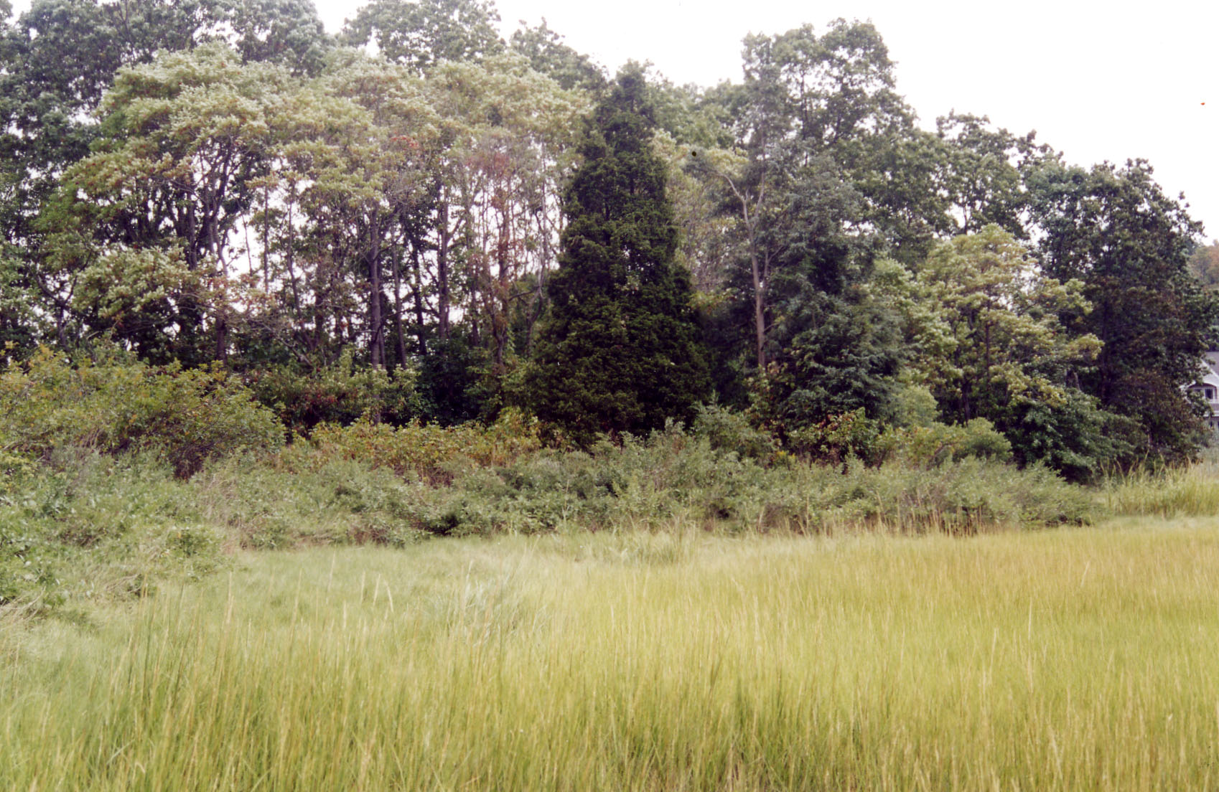

Figure 8. This sketch by Livia of the western marsh edge is looking southeast from the west side of Roton road. The trees are sassafras (probably about 20 years old). Sassafras would do well in this habitat and they spread clonely once established and are very native. The pyramidal trees are red cedar - also trees which are very native to the coastal shrub habitat. Sumac, marsh elder, poison ivy, Virginia creeper, might make up the understory.

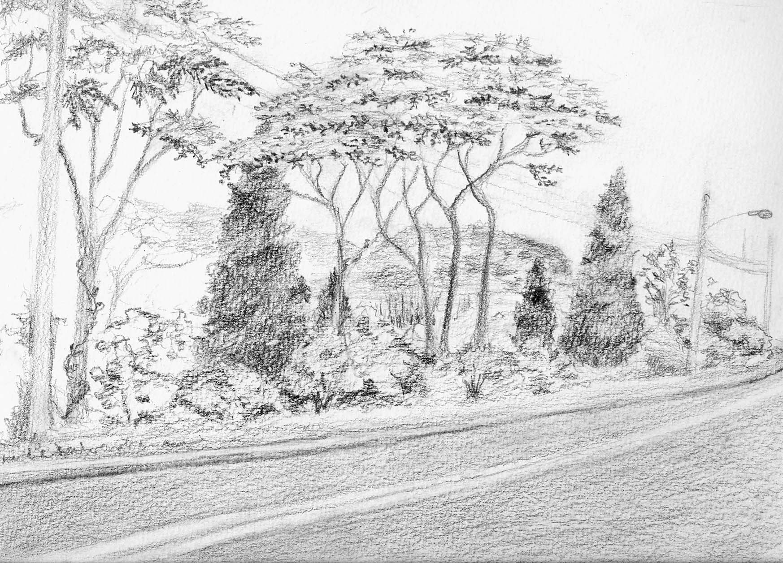

Figure 9. This sketch (Livia) is what the western edge might look like look in from the marsh - the reverse of the preceding presentation. Again same species but and without phragmites.

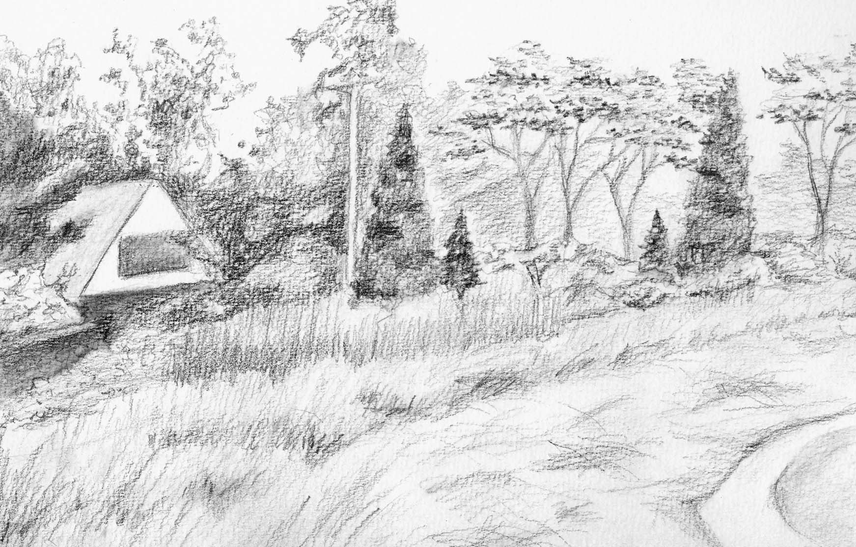

Figure 10. This is the lawn near the bridge that has been mowed the longest. A detailed mapping of the soil would be interesting to see how much is fill, if any is natural marsh sediment, and whatever other underground subtleties account for the subtle patterns in the vegetation shown. I think this lawn is mowed about 2 inches too short - it would be interesting to raise the mower - I think that would allow for a more lush marsh grass and still keep out the Phragmites. This grass is Distichlis - a high marsh grass.

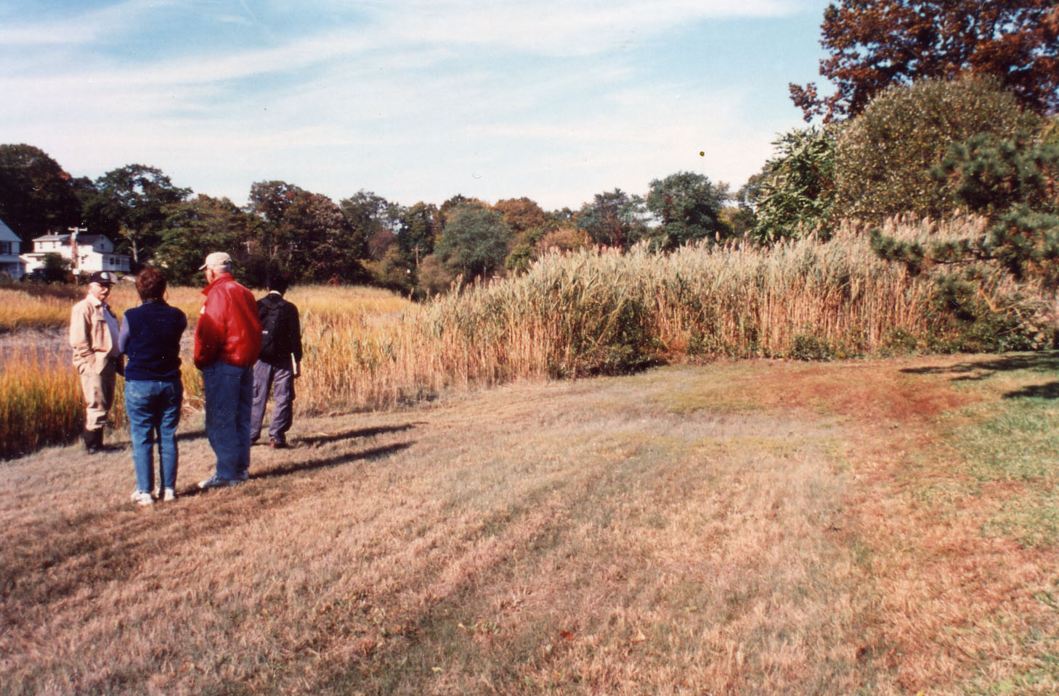

Figure 11. This "lawn" which is further north has had the Phragmites mowed so recently that there has been no opportunity for the Distichlis to become established. The mowing would have to continue for several years to really beat back the Phragmites and allow the other grass to get established. Planting "plugs" of Distichlis could possibly speed up the conversion. It will look like hell for a while - but that is the price to pay for converting.

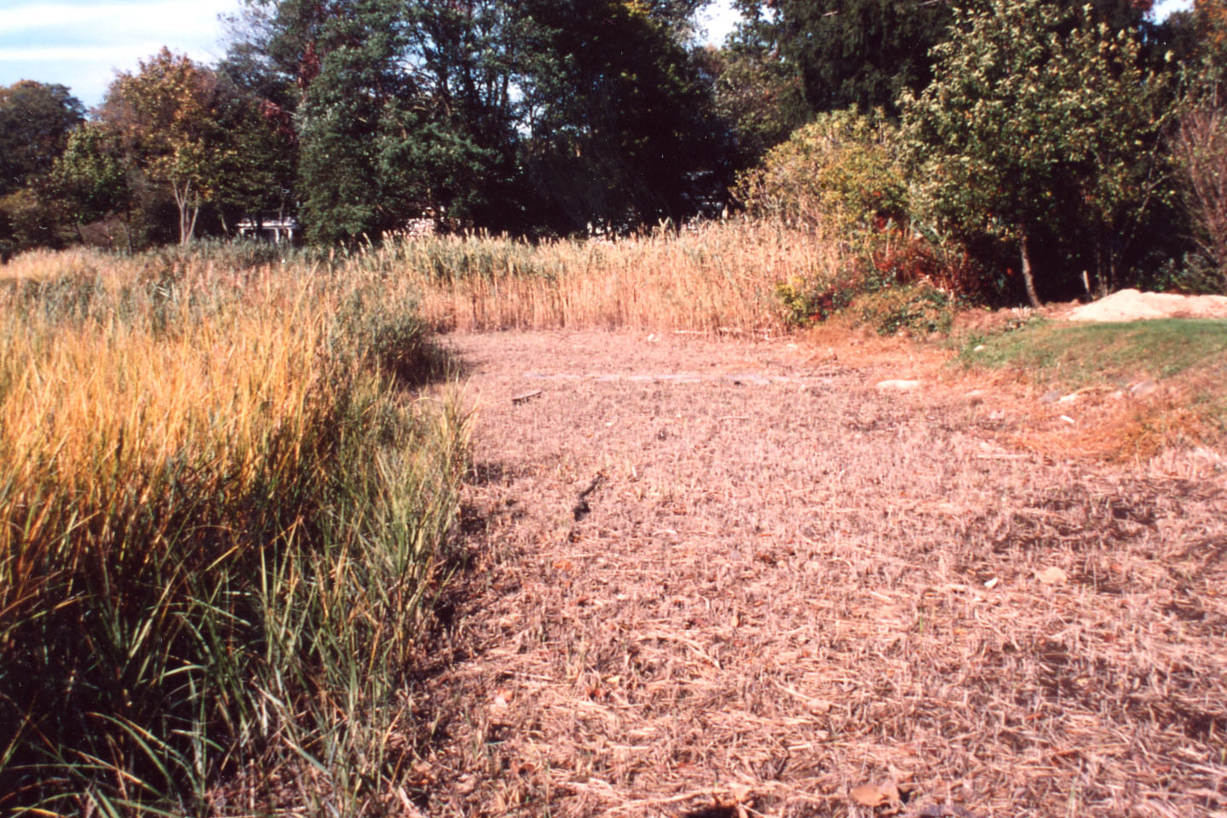

Figure 12. We think this is the "lawn" a little further north which was mowed and has possibly stopped being mowed - the Phragmites is creeping back in and the "good" grass is the Distichlis. Note the height of the Distichlis - a better height to make the grass thicker and grow better and still keep out the Phragmites. This mowing height is recommended for the first lawn down near the bridge.

